Waiata/Song  ‘Sprinkle a little sunshine on your day’  https://www.youtube.com/watch?v=FxD-CJfn7jU  Please click on the link above to enjoy a happy, fun waiata/song to dance and move around to! Enjoy! | Pukapuka/Story time  ‘The Very Hungry Caterpillar’  https://www.youtube.com/watch?v=75NQK-Sm1YY  Please click on the link above. Here is a classic story to listen to together as a whānau. | Calming Activity  ‘Children’s Yoga Adventure’  https://www.youtube.com/watch?v=2cNjAj_o0SI  Please click on the link above to enjoy some physical movement that allows for calmness as well. Great for tamariki/children and adults.
Seed balls  Seed balls are easy to make and fun to disperse.  Collect some -  clay, compost, and flower seeds.  Here is how to mix them –  Take the seeds, the compost and the clay and mix together. Add enough water so that the mixture can be rolled into balls. Once you have made the balls set them out in a shaded place to dry. They will be ready in a few days and can be dispersed from that time on.  Growing the seed balls –  Seed balls don’t get planted. They are simply scattered all over the place. Children can throw them, drop them, or simply place them on the ground.  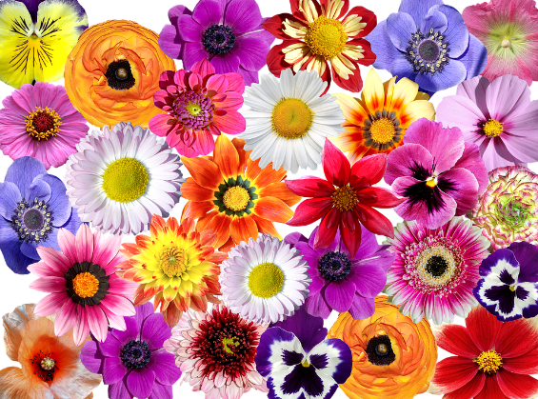  There is no need to water the seed balls. They will absorb moisture from the ground.  Have fun. | Rainbow Pizza  Ingredients  - 2 plain pizza bases  - 6 tbsp passata  - 400g mixed red and yellow tomatoes sliced  - 75g sprouting broccoli stems finely sliced  - 8 green olives, pitted and halved (optional)  - 2 tbsp fresh pesto  Grated cheese  Basil leaves to dress  Method  - Heat the oven to 180C/160C fan. Put each pizza base on a baking sheet and spread each with half of the passata. Arrange the tomatoes on the top in rings or wedges of colour and add the broccoli and the olives, if using. Add grated cheese then drizzle 1 tbsp pesto over each.  - Bake for 15-20 mins or until the top is bubbling and just starting to brown a little. Scatter over the basil leaves before serving.

